CONCEPTUAL DESIGN DOCUMENT

By

Ian Adelman

In Collaboration with

Devin Hoopes

Natalie Gonzalez

Alex Reinert

Submitted to Dr. Isenberg and Dr. Adams  
of Embry-Riddle Aeronautical University  
in Partial Fulfillment of the Course Requirements for ME 407 and COM 420

9/28/23

# ABSTRACT

In this document, a system designed to solve the problem statement shown below will be shown and described. An explanation for each component including how it adheres to a specific design requirement will be added.

TABLE OF CONTENTS

ABSTRACT

1.0 PROBLEM STATEMENT

2.0 REQUIREMENTS

2.1 FUNCTION

2.2 INTERFACING

2.3 SAFETY

3.0 SYSTEM OVERVIEW

3.1 CONCEPT OF OPERATIONS

3.2 SYSTEM COMPONENTS

3.2.1 Robotic Legs

3.2.2 Furniture Platform

3.2.3 Camera and Sensors

3.2.4 Balancing Linear Actuators

4.0 CONCLUSION

5.0 APPENDIX

6.0 ACKNOWLEDGEMENTS

7.0 REFERENCES

# PROBLEM STATEMENT

Transporting heavy furniture up and down one flight of straight stairs is difficult and potentially dangerous.

2.0 REQUIREMENTS

## 2.1 FUNCTION

To achieve the goal set by the problem statement, the requirements of function are as follows:

2.1.1 - The system shall transport furniture repeatedly up and down one floor within a residential building.

2.1.2 - The system shall accommodate up to a 4-seater sofa.

2.1.3 - The system shall accommodate up to a 5-shelf bookshelf.

2.1.4 - The system shall be reusable.

## 2.2 INTERFACING

To ensure that the system is of a proper size that is capable of being transported and capable of fitting within the stairwells it operates in, the requirements of interface are as follows:

2.2.1 - The system shall fit within a standard stairway according to Section R311.7.1 of the 2021 International Residential Code (IRC)

2.2.2 - The system shall be transportable in the back of an average American pickup truck in addition to the transported furniture.

## 2.3 SAFETY

To ensure that the system is overall safe, and does not endanger the operator or environment, the requirements of safety are as follows:

2.3.1 - The system shall cause less injury and strain than an average moving job.

2.3.2 - The system shall not destructively alter the environment.

2.3.3 - The system shall not damage the furniture.

# 3.0 SYSTEM OVERVIEW

## 3.1 CONCEPT OF OPERATIONS

The system operation is as follows. The robot is placed at the base of a straight staircase conforming to the 2021 International Residential code standards of construction. The furniture is then loaded onto the robot and secured via straps. The robot is then activated and will stand up. Next the operator will pilot the robot up the stairs using a controller. Once at the top of the stairs, the robot will be deactivated, and the furniture may be removed.

## 3.2 SYSTEM COMPONENTS

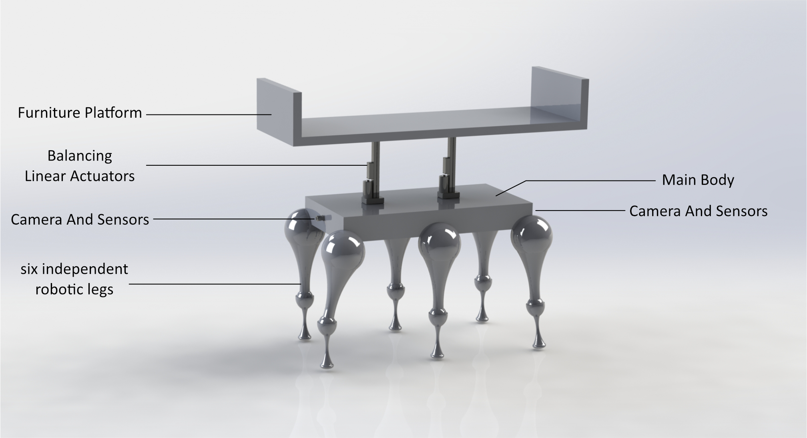

### 3.2.1 Robotic Legs

The main component and feature of this design are the 6 individually controllable robotic legs. These components are key to many of the system’s requirements: 2.1.1-2.1.4, 2.2.2, 2.3.1-2.3.3. The legs must be specified to bear the weight of furniture they will hold, and as they are will be controlled to move the robot itself with the furniture being carried, this will fulfil requirements 2.1.1-2.2.4. In addition to this, these legs are designed to be compact enough to be transported with the furniture they carry, 2.2.1, and also do not exceed a maximum width of 25 inches, making them fit within the minimum coded width of a staircase. That width being 27 inches as specified in, 2.2.1. Furthermore, the legs will carry the weight of the furniture instead of a human mover, as such they will reduce the injury and strain of moving 2.3.1. Lastly, the legs will be made as to not damage any of the surroundings they contact, 2.3.2.

### 3.2.2 Furniture Platform

The Furniture Platform component is where the carried furniture will be placed for they system to carry it. In addition to the modeled detail, there will be designed areas for straps or other mounting/holding equipment to be attached to insure a secure hold on the furniture. This component does not damage the furniture, and as such satisfies 2.3.3. In addition, the platform is sized to accommodate the specified 4-seater couch and 5-shelf bookshelf as in requirements 2.1.2 and 2.1.3.

### 3.2.3 Camera and Sensors

The camera and sensors are located on the front and back of the robot. The sensors portion is left intentionally vague as the possibility of many options and feasibility will be resolved at a later stage of the project. The Camera and sensors serve as an important safety measure and functionality aid. As the relevant codes allow for large variations in the geometry of the staircases, the Camera and Sensors will aid the system to navigate all possible coded stairs. This satisfies 2.1.1 as well as 2.2.1.

### 3.2.4 Balancing Linear Actuators

The balancing linear actuators are key to the safety and function of the system as they allow for partial orientation control of the Furniture Platform, thereby giving the system a level of control over its balance. This way, it’s possible for the system to account for differently shaped and weighted furniture safely, thereby adhering to 2.1.1, 2.1.2, and 2.1.3.

### 3.2.4 Main Body

The Main Body of the system houses all of the electronics and internals necessary for the function of the robot as a whole. It along with the robotic legs stays within the minimum coded dimensions of a stairway, satisfying 2.2.1.

# 4.0 CONCLUSION

As shown in the above explanations. This system concept is undoubtedly capable of performing all required actions and adhering to all requirements as intended. It can achieve its task while also reducing manual moving strain and increasing safety.

# 5.0 APPENDIX

|  |  |  |  |  |  |  |
| --- | --- | --- | --- | --- | --- | --- |
| **No.** | **Requirement** | **Verification Description** | **T** | **A** | **O** | **R** |
| 1 | 2.1.1 | Test load and trial | X |  |  |  |
| 2 | 2.1.2 | Measurement/Trial | X | X |  |  |
| 3 | 2.1.3 | Measurement/Trial | X | X |  |  |
| 4 | 2.1.4 | Repeated Trials | X |  | X |  |
| 5 | 2.2.1 | Measurement and Comparison | X |  |  | X |
| 6 | 2.2.2 | Measurement and Comparison | X |  |  | X |
| 7 | 2.3.1 | Trial, followed by Analysis and Comparison | X | X | X | X |
| 8 | 2.3.2 | Trial and Observation | X |  | X |  |
| 9 | 2.3.3 | Trial and Observation | X |  | X |  |

**T** – Test and Measurement; **A** – Analysis and Simulation;   
**O** – Observation and Inspection; **R** – Reference and Datasheet

(*Requirements verification matrix. | download table - researchgate*) [1]

# 

# 6.0 ACKNOWLEDGEMENTS

The design of the robotic legs is inspired by and roughly modeled based off of the Boston Dynamics Spot Robot [2]

# 7.0 REFERENCES

[1] “Table 1. Requirements Verification Matrix.,” ResearchGate. Accessed: Sep. 29, 2023. [Online]. Available: https://www.researchgate.net/figure/Requirements-Verification-Matrix_tbl1_269163835

[2] “Spot | Boston Dynamics.” Accessed: Sep. 29, 2023. [Online]. Available: https://bostondynamics.com/products/spot/